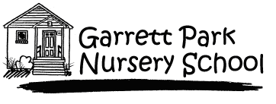

APPLICATION FOR ADMISSION
2018-2019

Please complete and return this form by mail along with the $40.00 non-refundable application fee to:

Garrett Park Nursery School
P.O. Box 314
Garrett Park, MD 20896

Child’s Name ______________________________________ Sex: M___F___

Date of Birth _______________________ Home Phone ___________________

Home Address _____________________________________________________

Email Address(es) __________________________________________________

Parent’s Name ______________________ Work/Cell Phone _______________

Parent’s Name ______________________ Work/Cell Phone ________________

You are applying for the school year 2018 to 2019. The child must be the appropriate age for the class by September 1, 2018.

___ 2 Year Old Program Tuesday & Thursday 9:15 am to 11:45am
___ 3 Year Old Program Monday, Wednesday, Friday 9:15 am to 11:45am
___ 4 Year Old Program Monday – Friday 9:15 am to 11:45am

Has any member of your immediate family been in the school before?

___ NO
___ YES If yes, relationship to child_______________________________
School year last enrolled_________________________________

How did you hear about our school: _______________________________________________

We do not discriminate on the basis of race, religion or place of natural origin.
GPNS requires current immunizations for every child enrolled in the school.

